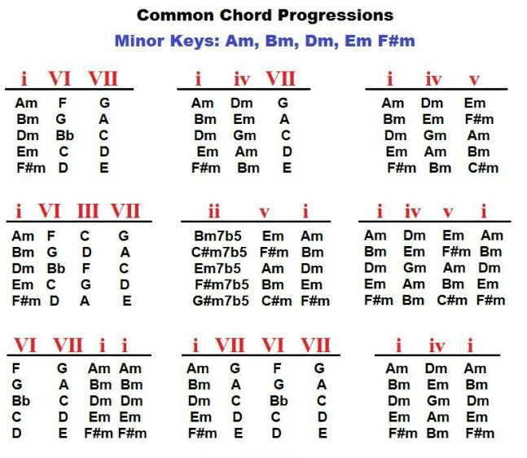
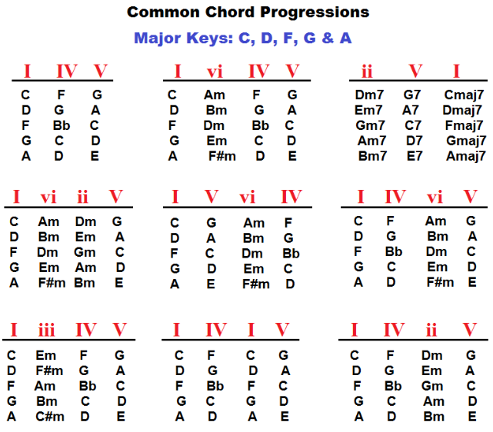
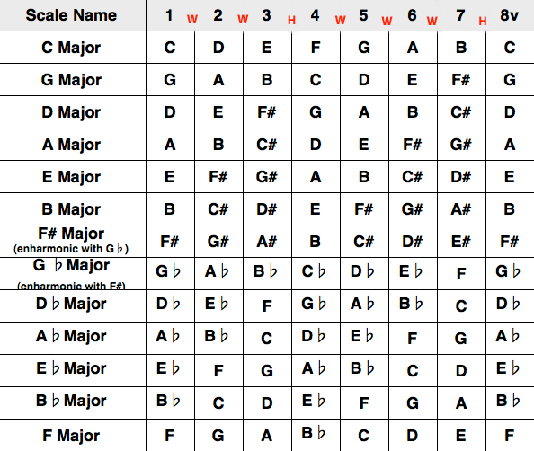
Major Chord – 1, 3, 5
Minor Chord – 1, 3b, 5
Major 7th – 1, 3, 5, 7
Dominant 7th – 1, 3, 5, 7b
Minor 7th – 1, 3b, 5, 7b

